Joseph Ayo

Module 5.2 Assignment – CSD 310

11/17/24

Function #1: INSERT()

When would you use it?: Whenever you want to insert a string into another string into a specific position in a table. Useful for partial string data modifications, fixing string typos, etc.

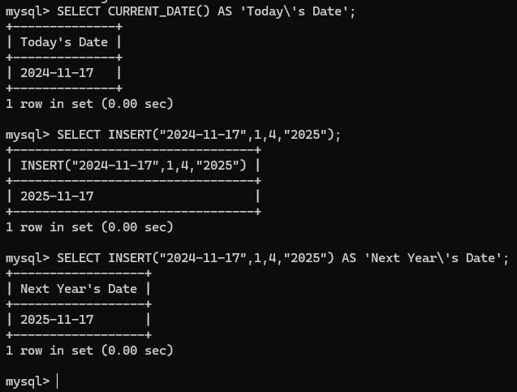

Function #2: FORMAT()

When would you use it?: Whenever you want to convert an unformatted number into something more legible and easier to quantify, such as when you wish to display numbers as currency.

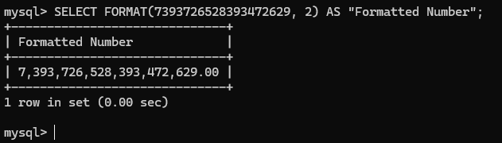

Function #3: REPLACE()

When would you use it?: When you wish to replace all of a given keyword in a given set. Useful for overriding specific data without deleting the entire row.

